Narrative Writing Assessment

Name_____________________________Date_________Grade______

Directions:

Choose a moment in time from your life, or choose one of the photographs as inspiration for a fictional moment.

You must use what you have learned about Slow Motion Writing to “Explode” a specific moment and develop it into a story. You will have two 45 minute periods in which to complete this piece.

My Moment Choice:

___________________________________________________________________

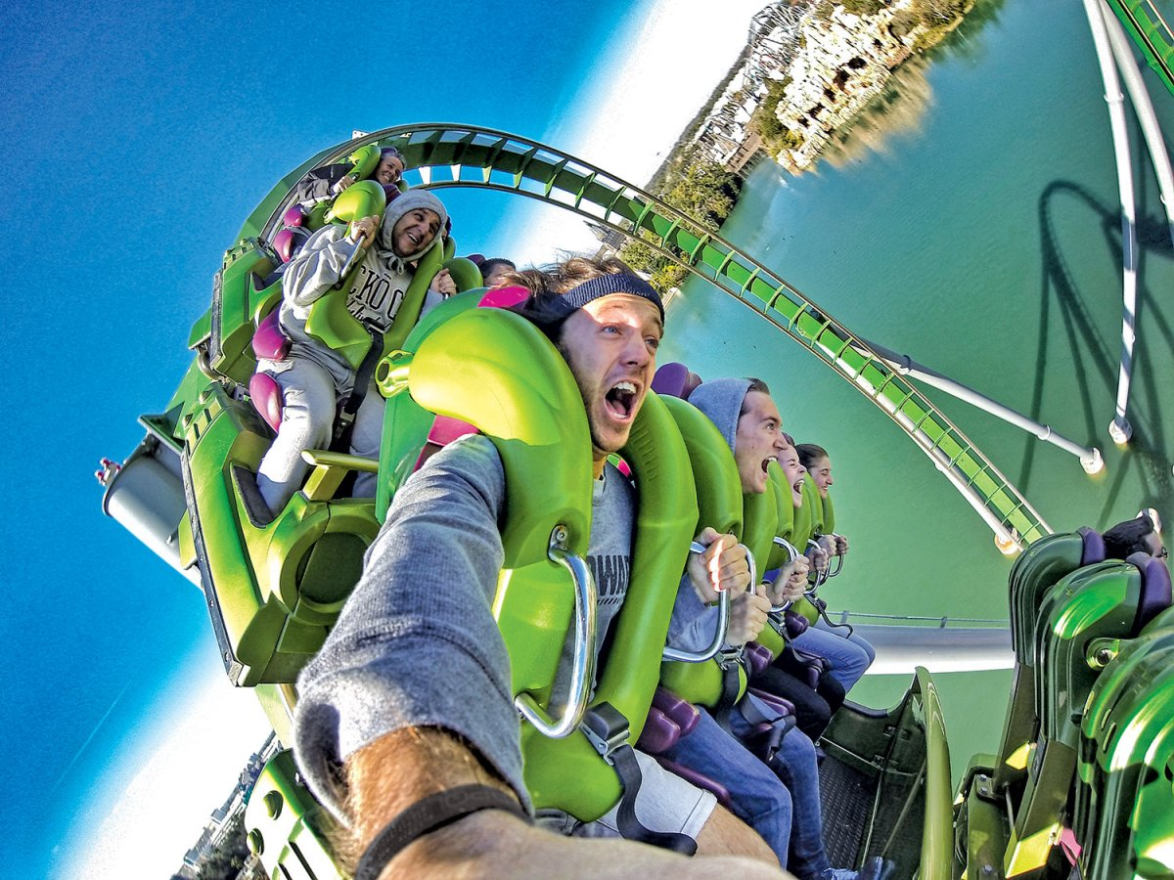

Suggested Steps

Name_______________________Date Grade______

Day 1

- Choose your personal moment or inspiration photo

- Brainstorm ideas about your narrative:
  - exploded moment
  - sensory details
  - thought shots
  - snapshots
  - descriptive words, similes, and metaphors

- Write your first draft

_____________________________________________________________________

Day 2

- Review the rubric, check for:
  - Did I answer the prompt?
  - Is my writing clearly organized?
  - Did I use narrative techniques to “Explode a Moment”?
  - Did I use vivid descriptive language? Similes? Metaphors?

- Revise your first draft based on your answers to the questions above

- Edit for grade level spelling, mechanics, and grammar

- Write a final draft in neat handwriting

- Grade your final draft using your rubric

